
Mehran University of Engineering & Technology Jamshoro
Subject: Electronic Instrumentation Systems
Assignment

Finger Gesture Controlled Servo System
Using
Machine Learning

Submitted by
DANIYAL 22ES077

1. Introduction
Machine Learning and intelligent automation are becoming important in modern electronic instrumentation systems. Traditional control systems use fixed rules and manual calibration, whereas Machine Learning enables systems to learn from data and make intelligent decisions automatically.
This project presents a Finger Gesture Controlled Servo System using Computer Vision and Machine Learning. The system detects finger movement through a webcam and controls a servo motor based on the distance between the thumb and index finger.
The system uses:
- OpenCV for image processing
- MediaPipe for hand tracking
- ESP32 for servo control
- Machine Learning models for prediction and intelligent decision making
The project demonstrates real-time automation and intelligent control using sensor data and Machine Learning algorithms.

2. Objectives
The objectives of this project are:
- To detect hand gestures using a webcam
- To calculate finger distance using image processing
- To control servo motor angle based on finger movement
- To apply Machine Learning for intelligent prediction
- To evaluate system performance using graphs and accuracy metrics

3. Instrumentation System Description
3.1 Components Used

Component | Purpose
Webcam | Captures hand image
MediaPipe | Detects hand landmarks
OpenCV | Image processing
Arduino / ESP32 | Servo motor control
Servo Motor | Rotational movement

3.2 Working Principle
The webcam captures the user’s hand image in real time. MediaPipe detects the landmarks of the hand and extracts the coordinates of the thumb tip and index finger tip.
The Euclidean distance between these two fingers is calculated. This distance is converted into a servo motor angle. The servo motor rotates clockwise or anticlockwise according to the predicted angle.
Machine Learning is used to:
- Predict servo angle
- Predict movement direction

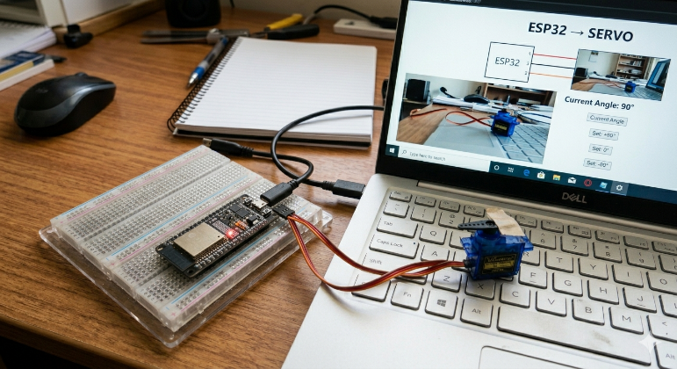
Figure 1: Hardware Setup

3.3 System Flow Diagram

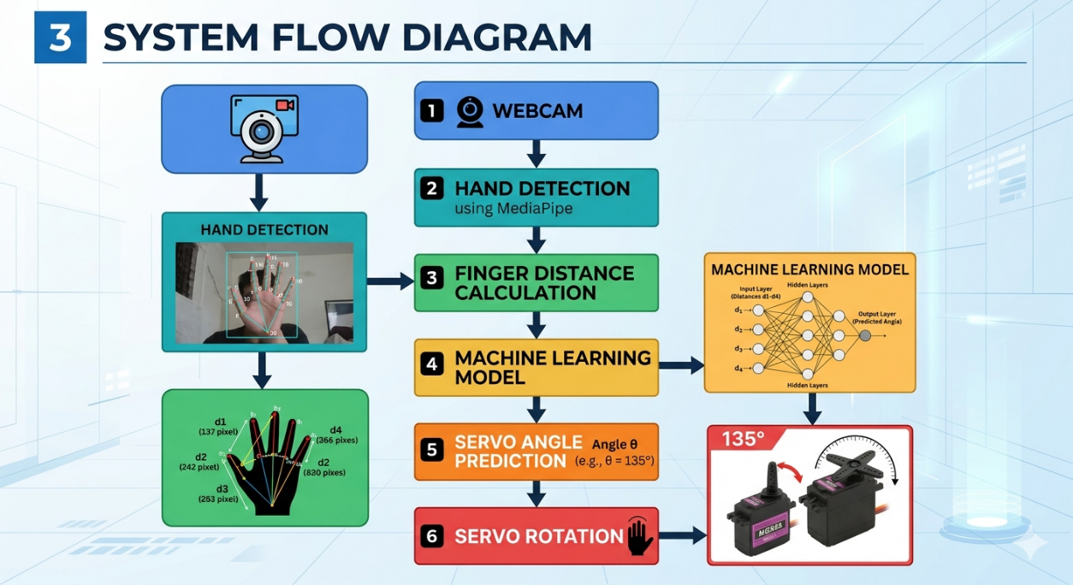
Figure 3: Block Diagram

4. Data Collection Method
The dataset was generated using finger distance and corresponding servo motor angle values.
The distance between thumb and index finger was recorded and mapped to servo motor angle.

4.1 Parameters Recorded
Parameter | Description
Distance | Finger distance
Servo_Angle | Servo rotation angle
Direction | Clockwise / Anticlockwise / Center

4.2 Dataset Size
- Total Samples: 600

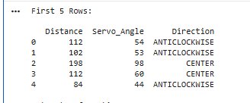
Figure 4: Dataset Screenshot

5. Data Preprocessing
The dataset was processed using Python in Google Colab.

5.1 Preprocessing Steps
- Loaded dataset using pandas
- Checked missing values
- Encoded direction labels
- Visualized dataset using graphs

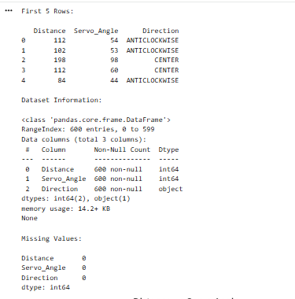

5.2 Direction Encoding
Direction | Encoded Value
ANTICLOCKWISE | 0
CENTER | 1
CLOCKWISE | 2

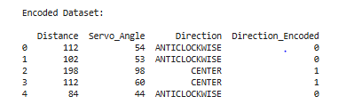

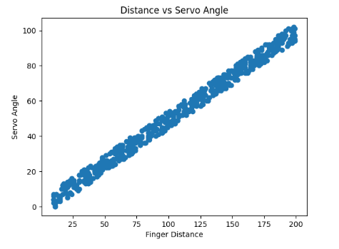
Figure 5: Distance vs Servo Angle
Explanation
This graph shows the relationship between finger distance and servo motor angle.

6. Machine Learning Method
Two Machine Learning models were used in this project.

6.1 Linear Regression
Linear Regression was used to predict the servo motor angle based on finger distance.
Inputs
- Finger Distance
Output
- Servo Angle

6.2 Decision Tree Classifier
Decision Tree was used to predict servo movement direction.
Inputs
- Distance
- Servo Angle
Output
- Clockwise
- Anticlockwise
- Center

6.3 Training Process
The dataset was divided into:
- 80% Training Data
- 20% Testing Data
The models were trained using Scikit-learn library.

7. Results and Analysis
The system performance was evaluated using prediction graphs and accuracy metrics.

7.1 Regression Results
The Linear Regression model successfully predicted servo angle based on finger distance.

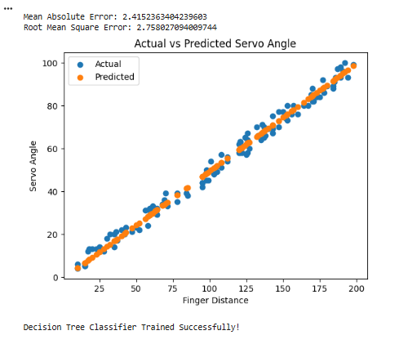
Figure 6: Actual vs Predicted Servo Angle
Explanation
The graph compares actual servo angle values with predicted values.

7.2 Error Analysis
The following metrics were used:
- Mean Absolute Error (MAE)
- Root Mean Square Error (RMSE)
These metrics show prediction accuracy of the regression model.

7.3 Classification Results
The Decision Tree model successfully predicted movement direction.

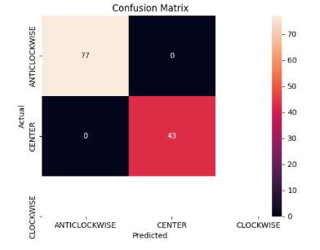
Figure 7: Confusion Matrix
Explanation

The confusion matrix shows correct and incorrect predictions.
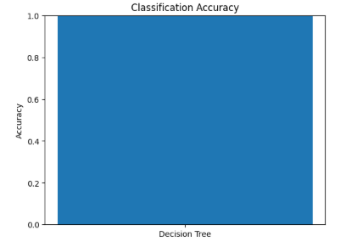
Figure 8: Classification Accuracy Graph
Explanation
The graph shows classification accuracy of the Decision Tree model.

8. Intelligent System Feature
The system demonstrates intelligent automation by predicting:
- Servo angle
- Servo movement direction
The system automatically responds to finger movement without manual control.

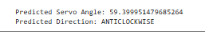
Figure 9: Output Prediction

9. System Integration
The project integrates:
- Computer Vision
- Electronic Instrumentation
- Machine Learning
- Real-Time Control
Traditional systems use fixed conditions, while this ML-based system learns from data and improves decision making.

10. Advantages of the System
- Real-time control
- Contactless interaction
- Intelligent automation
- Easy human-machine interaction
- Accurate servo movement prediction

11. Applications
- Robotics
- Smart automation
- Gesture-controlled systems
- Industrial control
- Assistive technology

12. Conclusion
A Finger Gesture Controlled Servo System was successfully developed using Machine Learning and Computer Vision.
The system detects finger movement, predicts servo angle, and controls servo direction intelligently. Machine Learning improves the system’s prediction capability and automation performance.
The project demonstrates the integration of instrumentation systems with intelligent data-driven techniques.

14. Source Code
14.1 Python Code

# ====================================================
# 1. IMPORT LIBRARIES
# ====================================================

import pandas as pd
import matplotlib.pyplot as plt
import seaborn as sns

# ====================================================
# 2. LOAD DATASET
# ====================================================

data = pd.read_csv("finger_servo_dataset.csv")

print("First 5 Rows:\n")
print(data.head())

# ====================================================
# 3. CHECK DATASET INFORMATION
# ====================================================

print("\nDataset Information:\n")
print(data.info())

print("\nMissing Values:\n")
print(data.isnull().sum())

# ====================================================
# 4. DATA VISUALIZATION
# ====================================================

# Distance vs Servo Angle

plt.figure()
plt.scatter(data['Distance'], data['Servo_Angle'])
plt.xlabel("Finger Distance")
plt.ylabel("Servo Angle")
plt.title("Distance vs Servo Angle")
plt.show()

# ====================================================
# 5. ENCODE DIRECTION LABELS
# ====================================================

data['Direction_Encoded'] = data['Direction'].map({
'ANTICLOCKWISE': 0,
'CENTER': 1,
'CLOCKWISE': 2
})

print("\nEncoded Dataset:\n")
print(data.head())

# ====================================================
# 6. MACHINE LEARNING - REGRESSION
# Predict Servo Angle
# ====================================================

from sklearn.model_selection import train_test_split
from sklearn.linear_model import LinearRegression

# Input and Output
X_reg = data[['Distance']]
y_reg = data['Servo_Angle']

# Split Dataset
X_train_reg, X_test_reg, y_train_reg, y_test_reg = train_test_split(
X_reg, y_reg, test_size=0.2
)

# Train Model
reg_model = LinearRegression()
reg_model.fit(X_train_reg, y_train_reg)

print("\nLinear Regression Model Trained Successfully!")

# Prediction
y_pred_reg = reg_model.predict(X_test_reg)

# ====================================================
# 7. REGRESSION PERFORMANCE
# ====================================================

from sklearn.metrics import mean_absolute_error, mean_squared_error
import numpy as np

mae = mean_absolute_error(y_test_reg, y_pred_reg)

rmse = np.sqrt(mean_squared_error(y_test_reg, y_pred_reg))

print("\nMean Absolute Error:", mae)
print("Root Mean Square Error:", rmse)

# ====================================================
# 8. REGRESSION GRAPH
# ====================================================

plt.figure()
plt.scatter(X_test_reg, y_test_reg, label="Actual")
plt.scatter(X_test_reg, y_pred_reg, label="Predicted")
plt.xlabel("Finger Distance")
plt.ylabel("Servo Angle")
plt.title("Actual vs Predicted Servo Angle")
plt.legend()
plt.show()

# ====================================================
# 9. MACHINE LEARNING - CLASSIFICATION
# Predict Servo Direction
# ====================================================

from sklearn.tree import DecisionTreeClassifier

# Inputs and Outputs
X_cls = data[['Distance', 'Servo_Angle']]
y_cls = data['Direction_Encoded']

# Split Dataset
X_train_cls, X_test_cls, y_train_cls, y_test_cls = train_test_split(
X_cls, y_cls, test_size=0.2
)

# Train Classifier
cls_model = DecisionTreeClassifier()

cls_model.fit(X_train_cls, y_train_cls)

print("\nDecision Tree Classifier Trained Successfully!")

# Prediction
y_pred_cls = cls_model.predict(X_test_cls)

# ====================================================
# 10. CLASSIFICATION ACCURACY
# ====================================================

from sklearn.metrics import accuracy_score

accuracy = accuracy_score(y_test_cls, y_pred_cls)

print("\nClassification Accuracy:", accuracy)

# ====================================================
# 11. CONFUSION MATRIX
# ====================================================

from sklearn.metrics import confusion_matrix

cm = confusion_matrix(y_test_cls, y_pred_cls)

plt.figure()

sns.heatmap(
cm,
annot=True,
fmt='d',
xticklabels=['ANTICLOCKWISE','CENTER','CLOCKWISE'],
yticklabels=['ANTICLOCKWISE','CENTER','CLOCKWISE']
)

plt.xlabel("Predicted")
plt.ylabel("Actual")
plt.title("Confusion Matrix")
plt.show()

# ====================================================
# 12. ACCURACY GRAPH
# ====================================================

plt.figure()

plt.bar(["Decision Tree"], [accuracy])

plt.ylim(0,1)

plt.ylabel("Accuracy")

plt.title("Classification Accuracy")

plt.show()

# ====================================================
# 13. TEST WITH NEW INPUT
# Intelligent Feature
# ====================================================

sample = pd.DataFrame([[120]], columns=['Distance'])

predicted_angle = reg_model.predict(sample)

print("\nPredicted Servo Angle:", predicted_angle[0])

# Direction Prediction

sample2 = pd.DataFrame(
[[120, predicted_angle[0]]],
columns=['Distance', 'Servo_Angle']
)

direction_prediction = cls_model.predict(sample2)

direction_map = {
0: "ANTICLOCKWISE",
1: "CENTER",
2: "CLOCKWISE"
}

print("Predicted Direction:",
direction_map[direction_prediction[0]])

ESP32 Code

import cv2
import mediapipe as mp
import serial
import time
import math

# CHANGE YOUR COM PORT
esp = serial.Serial('COM3', 115200)
time.sleep(2)

mp_hands = mp.solutions.hands
hands = mp_hands.Hands(max_num_hands=1)
draw = mp.solutions.drawing_utils

cap = cv2.VideoCapture(0)

def distance(x1, y1, x2, y2):
return math.sqrt((x2-x1)**2 + (y2-y1)**2)

while True:
success, img = cap.read()
img = cv2.flip(img, 1)

rgb = cv2.cvtColor(img, cv2.COLOR_BGR2RGB)
result = hands.process(rgb)

if result.multi_hand_landmarks:
for hand in result.multi_hand_landmarks:
draw.draw_landmarks(img, hand)

h, w, c = img.shape

# Thumb tip (4) and Index tip (8)
x1 = int(hand.landmark[4].x * w)
y1 = int(hand.landmark[4].y * h)

x2 = int(hand.landmark[8].x * w)
y2 = int(hand.landmark[8].y * h)

dist = distance(x1, y1, x2, y2)

# Convert distance to angle
angle = int(dist / 2)

# limit 0–180
if angle < 0:
angle = 0
if angle > 180:
angle = 180

# send to ESP32
esp.write(f"{angle}\n".encode())

print("Angle:", angle)

cv2.imshow("Finger Control Servo", img)

if cv2.waitKey(1) & 0xFF == ord('q'):
break

14. References
- Arduino IDE Documentation
- Scikit-learn Documentation
- OpenCV Documentation
- MediaPipe Documentation

